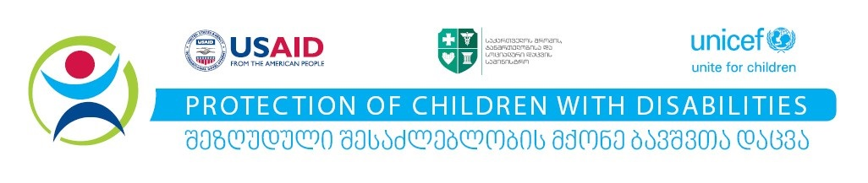
Ministry of Internally Displaced Persons from the Occupied Territories, Labour, Health and Social Affairs of Georgia,
UNICEF and International Chamber of Commerce

cordially invite you to the roundtable meeting:

“Business For Child Welfare”

on April 12, 11:00

“Radisson Blu Iveria”,
1 Rose Revolution Square, Tbilisi.

See the enclosed agenda of the meeting

Please RSVP to m@shurghulaia@icc.ge until April 8
